Introduction
The prediction of student academic performance has drawn considerable attention in education. However, although the learning outcomes are believed to improve learning and teaching, prognosticating the attainment of student outcomes remains underexplored. A decade of research work conducted between 2010 and November 2020 was surveyed to present a fundamental understanding of the intelligent techniques used for the prediction of student performance, where academic success is strictly measured using student learning outcomes (Namoun & Alshanqiti, 2021).
The second part covers the level of measurement in data analytics by categorizing the data as Nominal, Ordinal, Interval/ratio. The second part also covers the four different data analytics types such as Descriptive, Diagnostic, Predictive, Prescriptive. The third part discusses the three business problems in the context of the education industry. Lastly the fourth part discusses the conclusion.

2. Data Analytics
Data analytics in higher education provides unique opportunities to examine, understand, and model pedagogical processes. Consequently, the methodologies and processes underpinning data analytics in higher education have led to distinguishing, highly correlative terms such as Learning Analytics (LA), Academic Analytics (AA), and Educational Data Mining (EDM), where the outcome of one may become the input of another (Nguyen et al., 2020).

2.1 Types of Data
2.1.1 Nominal Data
Nominal data is a type of qualitative data which groups variables into categories. You can think of these categories as nouns or labels; they are purely descriptive, they don’t have any quantitative or numeric value, and the various categories cannot be placed into any kind of meaningful order or hierarchy (Stevens, 2022).
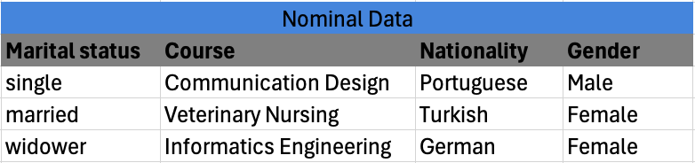
Figure 1: Nominal Data Example
2.1.2 Ordinal Data
Ordinal data classifies data while introducing an order, or ranking. For instance, measuring economic status using the hierarchy: ‘wealthy’, ‘middle income’ or ‘poor.’ However, there is no clearly defined interval between these categories (Hillier, 2023).
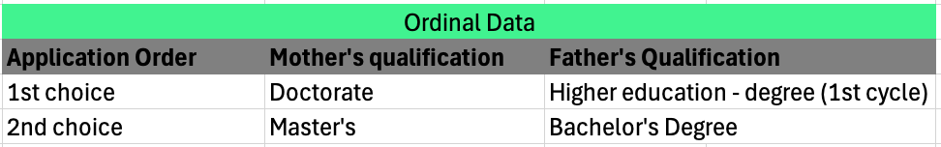
Figure 2: Ordinal Data Example
2.1.3 Interval/Ratio
Interval data are a level of measurement that involves data that’s naturally quantitative (is usually measured in numbers). Specifically, interval data has an order (like ordinal data), plus the spaces between measurement points are equal (unlike ordinal data). While ratio data is similar to interval data but the zero value implies absence of it (Jansen, 2020).
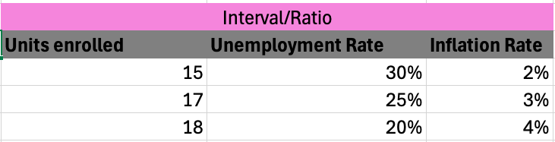
Figure 3: Interval/Ratio Data Example

2.2 Types of Data Analytics
Data analytics is the practice of using analytics tools to derive insights from datasets to inform decisions. With data analytics, organizations can improve decision-making, streamline operations, and increase revenue (Chen, 2024).
2.2.1 Descriptive Analytics
Using historical data analysis, descriptive analytics aims to comprehend past events. It entails compiling data, identifying patterns and gaining insights into or learning from past events (Yasar, 2024).
2.2.2 Diagnostics Analytics
Diagnostic analytics delves deeper into data to determine the reasons behind specific events. It involves identifying root causes, determining correlations and uncovering relationships between different variables (Yasar, 2024).
2.2.3 Predictive Analytics
Predictive analytics forecasts future patterns or events using statistical algorithms and historical data. It attempts to forecast future events and evaluate the probability of various scenarios. Predictive analytics works with algorithms and methodologies such as linear regression or logistic regression models (Yasar, 2024).
2.24 Prescriptive Analytics
Prescriptive analytics goes beyond predicting future outcomes to recommend specific actions for decision-making. It uses optimization and simulation techniques to determine the best course of action for desired outcomes (Yasar, 2024).

3. Impact of Data Analytics in the Education Industry
This part aims to identify three business problems concerning student performance and its impact on different contexts through the application of data analytics. By using data-driven analytics, educational institutions can affirm these problems and make calculated, well-informed decisions for the sake of the students, the institution.

3.1 Problem 1: Enhance Student outcomes

3.2 Early identification of At Risk Students / Predicting Student Performance
At university level studies, the students usually abandon some subjects in which they were enrolled in for the academic year. Students would initiate this dynamic by skipping, or not attending, lectures, sometimes due to neglect or carelessness, while at other times as a result of their lack of understanding of the subject. Consequently, they would lose track of the class agenda followed by the professor. Yet, when they would attend after some time of absence, they would discover, upon their return, that they would get discouraged by their lack of understanding, which in turn would decide not to return to lectures, and study on their own. However, some of these students do fail to turn up for their final exams, while the fail rate of those who actually take the exams are high. The bigger problem occurs when the events described happen often to a student, a recurrence that could constitute the beginning of dropouts from college. This is a topic of concern in the universities, especially in the early grades. Dropouts by college students is a hot topic at present, there are many analysis carried out on the subject, trying to find the causes of it, whether it is social, family related, organizational, personal (M. Gascueña & Guadalupe García, 2012). Academic failure increased the likelihood of course attrition by 4.2 times. The students who failed and persisted attributed academic failure to a conﬂuence of dispositional, situational, and institutional factors. There was a compounded eﬀect of academic failure on already-vulnerable students resulting in strong negative emotions (Ajjawi et al., 2020).
In today's educational landscape, accurately predicting academic performance remains a critical challenge. Traditional methods often rely on limited data sources and fail to capture the complexity of factors influencing student success (Bagade, 2024).
Using Predictive and Prescriptive Analytics would be the most ideal approach to properly study these nominal, ordinal, interval, and ratio variables like ‘grades’, ‘ethnicity’, ‘study time’, etc.. These analysis would provide various information, from determining which students might need school help to get back on their feet, and what these students could do to improve their grades. Through building models for early prediction of study outcomes, then evaluating the models using cross-validation and misclassification errors to decide which model which model outperforms other models in terms of classification accuracy, we can present predictive results that can be easily understood by students, teachers, and academic staff (Kovačić & Green, 2010). It is crucial to identify at-risk students as early as possible during a course. With the shortcomings of current academic early warning systems it is important to develop prediction models with high accuracy for at-risk students (Marbouti et al., 2016).

3.3 Improving graduation rates

3.4 Improve Student Retention Strategies
Student retention is an important issue for higher education institutions as withdrawals from higher education prior to degree completion remain at about 30 % in the member countries of the Organisation for Economic Cooperation and Development (Mah, 2016). Early attrition, particularly within the first year of study, is attributed to a variety of reasons including students struggling with the transition to university, boredom, lack of interest, inadequate preparation, insufficient academic and social engagement, negotiating an appropriate balance between study-loads and personal commitments, and dissatisfaction with the course or university (Coates, 2014; Hobsons, 2014, as cited in Seidel & Kutieleh, 2017). This causes students to withdraw from their classes or studies.
Thus, higher education institutions have recently gained interest in collecting and mining these dynamic student data with learning analytics to gain insight into learners’ experiences and to predict and optimize learning processes (Ferguson, 2012; Fiaidhi, 2014; Ifenthaler, 2015; Ifenthaler et al., 2014; Long and Siemens, 2011, as cited in Mah, 2016). Furthermore, digital badges are a relatively new technology in educational settings for representing learners’ achievements, knowledge, skills, and competencies in formal and informal learning environments (EDUCAUSE, 2012; Gibson et al., 2013; Ifenthaler et al., 2016, as cited in Mah, 2016). Student retention focuses strongly on the student (understandable of course). Studies are interested in testing hypotheses by either exploring or explaining the perspective of the student. There are some examples (c.f. Thomas, 2002) of studies straying from this and instead looking at the perspective of the institution and how that affects students. In this regard, by u diagnostic, predictive and prescriptive analytics would be the most effective approach, identifying what is the probable cause, identifying student attrition, as well as prescribing ways to reduce student attrition. By analyzing student information such as student’s background (socio-economic), individual attributes (age, employment history, family situation, etc.), pre-college schooling (where they attended), and even residence (on or off campus). Also, the level of commitment, academic and social integration shown by the student were other factors used to quantify student retention risk (McCarthy, 2019).

4. Conclusion
In conclusion, using data analytics for educational institution can improve overall student outcomes and performance. By using various student data and analytical techniques, schools, universities, and other education institutions can gather highly valuable insights to address school problems such as student attrition, and student performance, etc. Descriptive and Diagnostic analytics are also helpful in this study but Predictive and Prescriptive analytics would be the ideal way to study student variables like ‘grades’, ‘ethnicity’, ‘study time’, to provide information on which student might need school help and what these students could do to improve their grades. It is crucial to identify at risk students as early as possible.

References
Ajjawi, R., Dracup, M., Zacharias, N., Bennett, S., & Boud, D. (2020). Persisting students’ explanations of and emotional responses to academic failure. Higher Education Research & Development, 39(2), 185–199. https://doi.org/10.1080/07294360.2019.1664999
Bagade, P. (2024). Enhanced Academic Performance Forecasting through Multisource Behavioral Data Analysis. International Research Journal of Innovations in Engineering and Technology, 8(8), 167–171. Publicly Available Content Database. https://doi.org/10.47001/IRJIET/2024.808018
Chen, M. (2024). What Is Data Analytics? An Overview of Methods and Practical Uses. Oracle. https://www.oracle.com/nz/business-analytics/data-analytics/
Hillier, W. (2023). What Is Ordinal Data? Careerfoundry. https://careerfoundry.com/en/blog/data-analytics/what-is-ordinal-data/
Jansen, D. (2020). Nominal, Ordinal, Interval & Ratio Data Levels Of Measurement: Explained Simply (With Examples). Gradcoach. https://gradcoach.com/nominal-ordinal-interval-ratio/
Kovačić, Z. J., & Green, J. S. (2010). Predictive working tool for early identification of ‘at risk’ students. Ako Aotearoa. https://ako.ac.nz/assets/Knowledge-centre/RHPF-c11-tool-for-early-identification-of-at-risk-students/RESEARCH-REPORT-Predictive-Working-Tool-for-Early-Identification-of-At-Risk-Students.pdf
M. Gascueña, C., & Guadalupe García, R. (2012). STUDY ABOUT THE PROBLEM OF DROPPING OF SUBJECTS BY STUDENTS DURING AN ACADEMIC YEAR AT THE UNIVERSITY. 2588–2597.
Mah, D.-K. (2016). Learning Analytics and Digital Badges: Potential Impact on Student Retention in Higher Education. Technology, Knowledge and Learning, 21(3), 285–305. https://doi.org/10.1007/s10758-016-9286-8
Marbouti, F., Diefes-Dux, H. A., & Madhavan, K. (2016). Models for early prediction of at-risk students in a course using standards-based grading. Computers & Education, 103, 1–15. https://doi.org/10.1016/j.compedu.2016.09.005
McCarthy, J. (2019). A data driven approach to student retention: The impact on leadership behaviour [PhD Thesis, University College Cork]. https://doi.org/10.1007/s10758-016-9286-8
Namoun, A., & Alshanqiti, A. (2021). Predicting Student Performance Using Data Mining and Learning Analytics Techniques: A Systematic Literature Review. Applied Sciences, 11(1). https://doi.org/10.3390/app11010237
Nguyen, A., Gardner, L., & Sheridan, D. (2020). Data analytics in higher education: An integrated view. International Journal of Computer Science Issues (IJCSI), 31(1), 61–71.
Seidel, E., & Kutieleh, S. (2017). Using predictive analytics to target and improve first year student attrition. Australian Journal of Education, 61(2), 200–2018.
Stevens, E. (2022). What is Nominal Data? Definition, Characteristics and Examples. Careerfoundry. https://careerfoundry.com/en/blog/data-analytics/what-is-nominal-data/
Yasar, K. (2024). Data analytics (DA). Techtarget. https://www.techtarget.com/searchdatamanagement/definition/data-analytics

